Operating system LAB
Name: Huzaifa Qureshi
Roll no: F2023332045
Professor: Talha Khalid

LAB TASK
1.
We created a folder named Huzaifa Qureshi f2023332045 and used “” for having space between the words.
2.
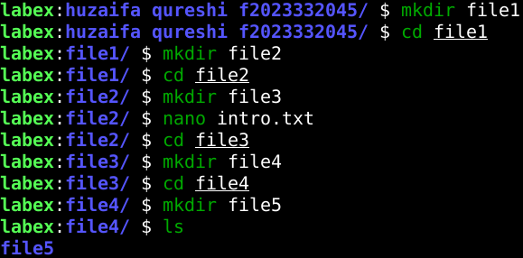
We created a folder within that folder with the name file1 and entered and created another one inside the previous one and so on till file5. And we created a text file named intro.txt within the file3.

3.
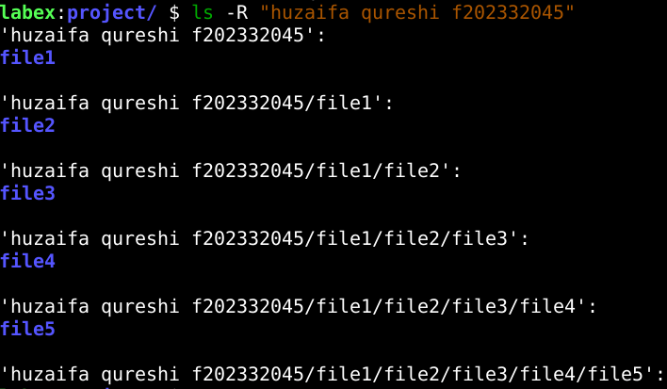
This is the structure of the whole nested folder system we created which we accessed using ‘ls -R’.
4/5.
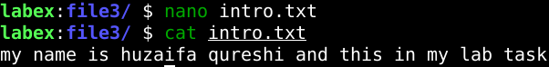
In this we entered the ‘file3’ and created a file named ‘intro.txt’ and accessed it using ‘cat intro.txt’ .

